Table 1. This table represents the values of each reference velocity that was input with its corresponding actual velocity for the three different proportional constants in Open Loop.
Kp | Reference Velocity (BDI / BTI) | Actual Velocity (BDI / BTI) | Kp | Reference Velocity (BDI / BTI) | Actual Velocity (BDI / BTI) | Kp | Reference Velocity (BDI / BTI) | Actual Velocity (BDI / BTI)
1 | 125 | 23 | 3 | 125 | 107 | 5 | 125 | 65
1 | 100 | 18 | 3 | 100 | 86 | 5 | 100 | 52
1 | 75 | 14 | 3 | 75 | 65 | 5 | 75 | 40
1 | 50 | 11 | 3 | 50 | 44 | 5 | 50 | 27
1 | 25 | 6 | 3 | 25 | 22 | 5 | 25 | 14
1 | 0 | 0 | 3 | 0 | 0 | 5 | 0 | 0
1 | -25 | 0 | 3 | -25 | -15 | 5 | -25 | -8
1 | -50 | -2 | 3 | -50 | -36 | 5 | -50 | -20
1 | -75 | -8 | 3 | -75 | -58 | 5 | -75 | -33
1 | -100 | -12 | 3 | -100 | -78 | 5 | -100 | -45
1 | -125 | -16 | 3 | -125 | -98 | 5 | -125 | -58

Figure 1. Reference velocity versus actual velocity for Open Loop. The slope of the line was used to acquire the motor constant, km.
Table 2.This table represents the values of each reference velocity that was input with its corresponding actual velocity for the three different proportional constants in Closed Loop.
Kp | Reference Velocity (BDI / BTI) | Actual Velocity (BDI / BTI) | Kp | Reference Velocity (BDI / BTI) | Actual Velocity (BDI / BTI) | Kp | Reference Velocity (BDI / BTI) | Actual Velocity (BDI / BTI)
1 | 125 | -13 | 3 | 125 | -38 | 5 | 125 | -54
1 | 100 | -10 | 3 | 100 | -30 | 5 | 100 | -42
1 | 75 | -6 | 3 | 75 | -21 | 5 | 75 | -31
1 | 50 | 0 | 3 | 50 | -13 | 5 | 50 | -20
1 | 25 | 0 | 3 | 25 | -5 | 5 | 25 | -8
1 | 0 | 0 | 3 | 0 | 0 | 5 | 0 | 0
1 | -25 | 5 | 3 | -25 | 9 | 5 | -25 | 12
1 | -50 | 9 | 3 | -50 | 18 | 5 | -50 | 23
1 | -75 | 12 | 3 | -75 | 26 | 5 | -75 | 35
1 | -100 | 16 | 3 | -100 | 34 | 5 | -100 | 46
1 | -125 | 19 | 3 | -125 | 43 | 5 | -125 | 58

Figure 2.Reference velocity versus actual velocity for Closed Loop. The slope of the line was used to acquire the motor constant, km.

Figure 3.Closed loop step response of the motor. The response was executed with parameters of: vref=100, Ki=0, and Kp=5. The Response yields a time constant of 0.0152 seconds.

Figure 4.Closed loop step response of the motor. The response was executed with parameters of: vref=100, Ki=0, and Kp=5. The Response yields a time constant of 0.01298 seconds.

Figure 5. Closed loop response of the motor. The experimental parameters were: Vref=100, Ki=1, Kp=5, Wn=78.55 rad/s.

Figure 6. Closed loop response of the motor, simulated and actual. The experimental parameters were: Vref=100, Ki=6.25, Kp=22, Wn=195.37rad/s.

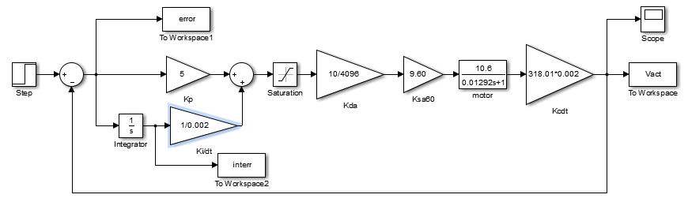
Figure 7. Simulink diagram used to acquire the simulated closed loop response of the motor for figure 5.

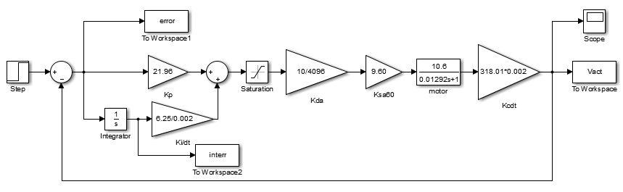
Figure 8.Simulink diagram used to acquire the simulated closed loop response of the motor for figure 6.

